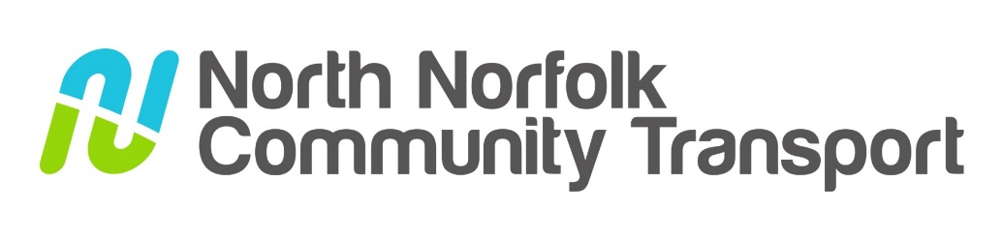

A summary of the report from our Executive Lead, Jane Bishop
AGM September 2024

In the financial year 2023/24 we provided a total of 15,495 trips on all our community transport services. These are Dial-a-ride, wheelchair accessible transport, excursions and group hire. Overall, there was an increase in our services of just over 23% on the previous year.

A notable change during the past year has been our success in recruiting some new volunteers. The excursions continue to be an extremely popular service and we have delivered almost twice as many trips as we promised in our National Lottery grant application. Despite this we have found the demand quite difficult to manage and it is credit to the team that they have done their best to make sure seats on the bus are fairly allocated. A huge amount of work goes into researching and planning the trips to ensure they are safe and suitable for our passengers. As our National Lottery funding comes to an end, a focus for next year will be to find grant funding to continue the excursions.

We have noticed the way people are using Dial-a-Ride is changing. In response to demand, we have already adapted the destinations so that people can reach some of the bigger towns such as Norwich and Kings Lynn. Other people are asking to go to the larger retail parks for shopping rather than market towns, reflecting a change in shopping habits. Local supermarkets still prove to be popular and essential for many of our beneficiaries.

Combatting loneliness and isolation is at the heart of our work, and at Christmas we organised a festive lunch so that everyone who wanted to attend could do so with free transport. We also send all our members a birthday card. Many people have phoned to thank us and said that this was the only card they received.
The cease of an annual grant of £40,000 from North Norfolk District Council is a big threat to our future services, but our continued relationship with them has yielded other opportunities. This included a recent grant for £50,000 from the Rural England Prosperity Fund towards an electric minibus.

As we put in place our Strategic Plan for the next five years, the results of our passenger survey give us cause to be proud of all aspects of our work, but we are mindful to keep checking our value and relevance. We would like to continue working with other organisations who identify lack of access to transport as a challenge.

Finally, using the Social Value Toolkit, we can calculate that during 2023/2024 financial year our transport activities across all services have created additional social benefits which can be attributed a value of £181,424.

