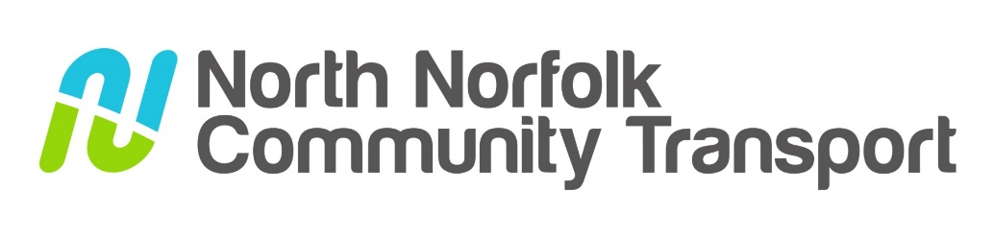

A summary of the report from our Chairman, Nigel Lloyd
AGM September 2024

I am pleased to report that there have been some notable successes for NNCT in the past year.
The charity has managed to increase passenger numbers which means we have reached out to more people in North Norfolk and hopefully helped to make a positive impact on their lives.
NNCT continue to rely heavily on the generosity of a wide range of funders from both the public and private sectors, for which we are extremely grateful. In an era of ever-increasing competition for this available grant money, we continue to have some success in obtaining sufficient funds to maintain our services. Indeed, I am pleased to report that we have been able to maintain and increase our reach to those who need affordable transport over the past year whilst also meeting our financial targets and maintaining a balanced budget.
We are pleased to have been able to replace aging vehicles this year, lowering the average age of the fleet. In turn this strategy will reduce our maintenance and running costs. Our goal of incrementally increasing our number of zero emission vehicles continues with the recent order for an electric bus which can carry 8 passengers or 3 wheelchairs. We will continue to closely monitor and report on our carbon emission with a view to reducing the environmental impact of our services year on year.
Despite our achievements over the past year, there remain some notable challenges and risks to the charity as we look forward. The national lottery funding comes to an end soon after nine years of significant annual funding. This money helped us through the difficult covid years whilst directly funding hundreds of trips each year. NNDC had generously funded community transport in North Norfolk since the charity was inaugurated in 2000 but are unable to maintain its support in future. The loss of these monies is a huge blow and will be difficult to replace but we will do everything in our power to maintain our current services to those in need of them.
Our successes this year are once again down to the brilliant leadership from our Executive Lead – Jane, our outstanding office team who work tirelessly to satisfy affordable transport needs in the area, our team of drivers whose professionalism and empathy are a huge credit to our charity and the increasing number of volunteer drivers who give up their time freely to help deliver our services. I take this opportunity to offer my sincere thanks to them all. Our team of volunteer Trustees are rarely seen but offer guidance, support and direction to the charity. My thanks also go out to them.
Next year is the 25th anniversary of delivering affordable transport solutions to people in the North Norfolk area. We hope to be able to celebrate the occasion with a range of events and initiatives.

